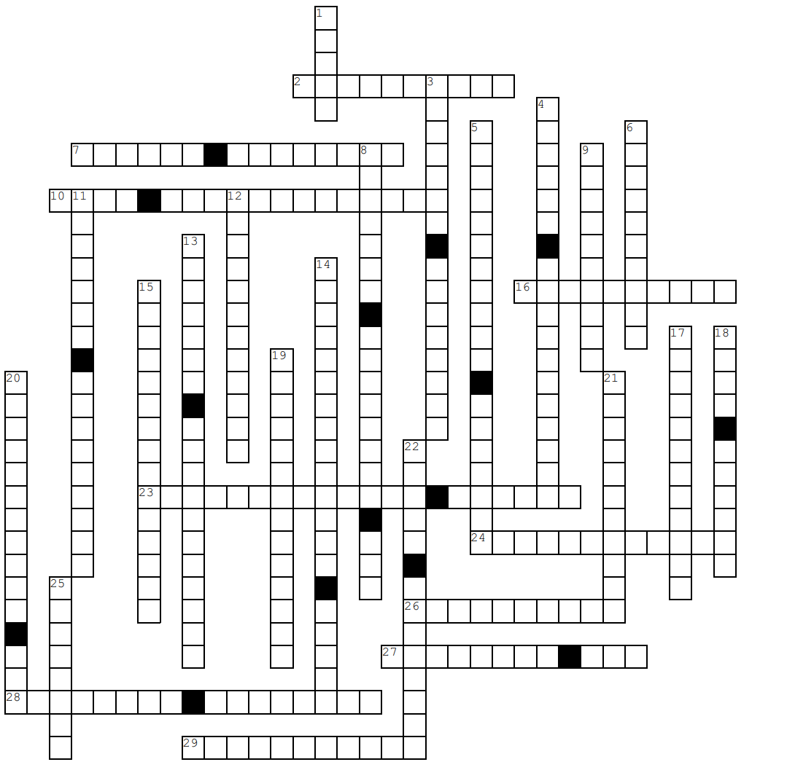**Vertical**

1. The part of a machine learning system that learns and predicts.

3. The science of teaching computers to learn from data without explicit programming.

4. Processing audio using RNNs, CNNs, or transformers.

5. Suggesting products or services to clients.

6. Learning from labeled examples.

8. Studying computer-human language interactions.

9. Grouping instances based on similarity.

11. Detecting rare events or outliers.

12. Learning without labels.

13. Selecting or creating relevant features.

14. Selecting best hyperparameters.

15. Predicting some part of input.

17. Model is too simple to learn data structure.

18. Discovering patterns in large amounts of data.

19. Constraining a model to reduce overfitting.

20. Subset of training set used to tune hyperparameters.

21. Collecting, cleaning, and transforming data.

22. Offline learning with all available data.

25. A performance measure for classification tasks. **Horizontal**

2. Deploying model to production environment.

7. Incremental learning with sequential data.

10. Representing data in a clear diagram.

16. Predicting numerical values.

23. Training agents to maximize rewards.

24. Detecting tumors by classifying each pixel.

26. Testing model performance on a separate test set.

27. A set of examples used to teach a machine learning system.

28. Each example in a training set.

29. Model fits training data too closely